Setting up your own Pfsense personal firewall

- Pfsense Firewall software can be installed on to barebones devices or with an ISO into a virtual machine (VM) you can use Rufus software to create a Bootable USB drive
https://www.pfsense.org/download/
https://rufus.ie/en/

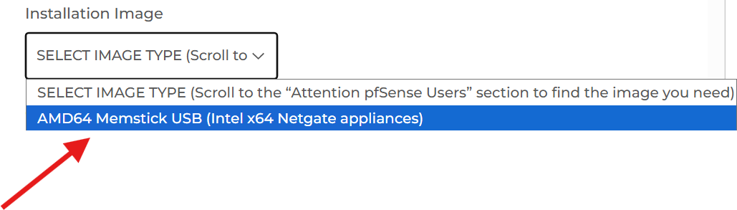
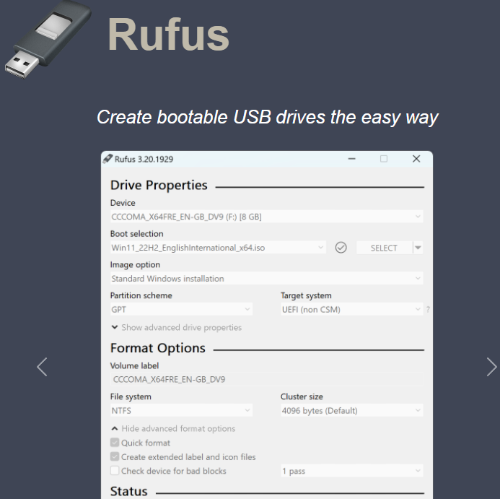

Purchase a Protectli Firewall appliance amazon.com/Firewall-Appliance-Gigabit-Celeron-AES-NI/dp/B07G9NHRGQ/ref=sr_1_3?crid=3TBVLWWGJYGA0&sprefix=Protectli+Firewall+appliance%2Caps%2C333&sr=8-3

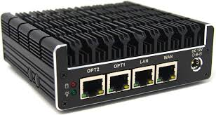

Setup your PFsense WAN with a connection directly to your Router then connecting to the WAN port, Then Connect the LAN port to a Switch or your PC directly
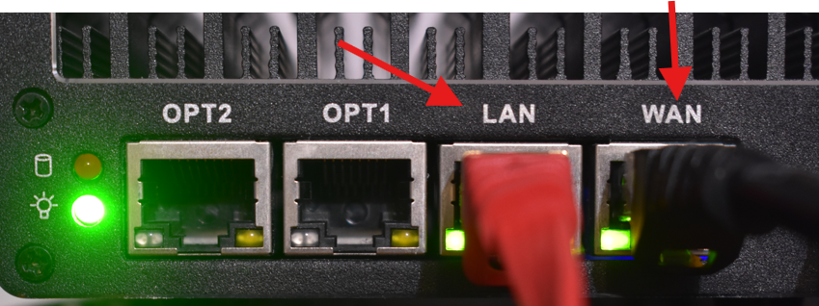

Then on the back of your Device Plug in a HDMI Monitor And Keyboard and your Usb Install Media.
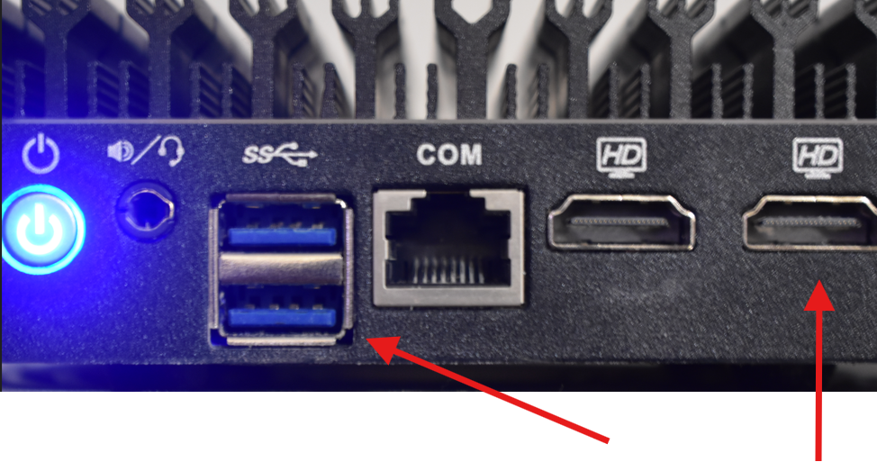

When first boot up you will see the splash screen


After the appliance is boot up all the way you will be greeted with this screen with the LAN address set to 192.168.1.1 go to your computer connected to your firewall and type that Address into your browser Address bar
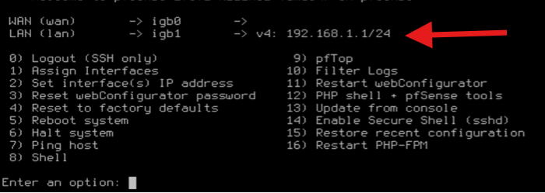
Important to note – if you also update your DHCP range if you every change the default from 192.168.1.1/24 OR YOU WILL BE LOCKED OUT FROM YOUR DEVICE

Once that is Setup your Display will provide you with the webconfiguation URL from the static IP address you gave as your LAN address. To setup your New PFSense Firewall appliance in this case http://192.168.1.1

You will Be greeted by this screen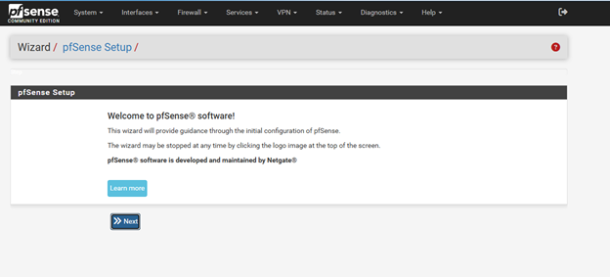

Click “Next”
Create A hostname for your Device your company or business Domain can be used as your domain if you would like. Create a Primary DNS Server Best Practice is to setup privacy-focused resolvers (1.1.1.1 or 1.0.0.1 or 8.8.8.8)
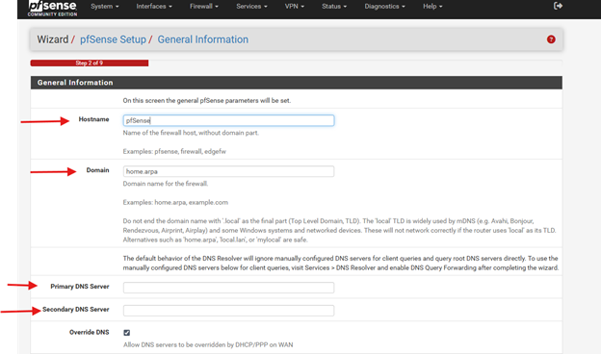

Set the Timezone for the device to follow
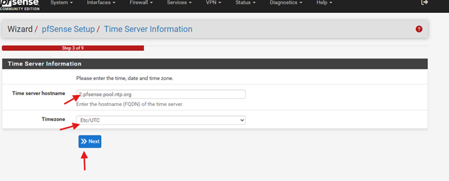

Configure the WAN Interface to be your DHCP to assign IP addresses out to other computer connected to (Switches/hubs)
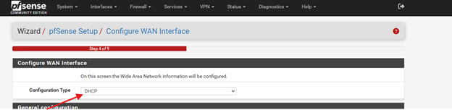

Configure What LAN address you would Like (ex 10.0.0.0.1/192.168.1.1/ 172.168.0.0)
We used 192.168.1.1
And Set the Subnet mask for how many devices you'd like connected
(Subnet /24 254 usable)
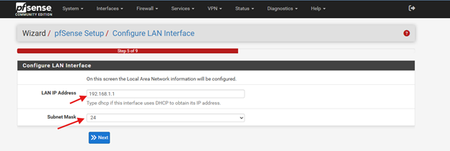

Create a New password then your New PFsense Firewall appliance is ready to use
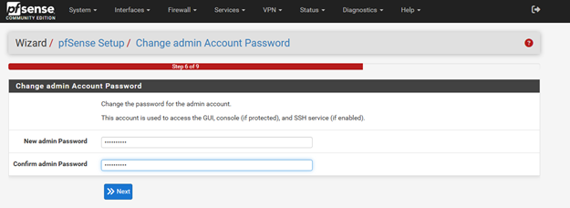
And You have compiled the Initial Setup for your pfsense Firewall appliance Click “Finish”
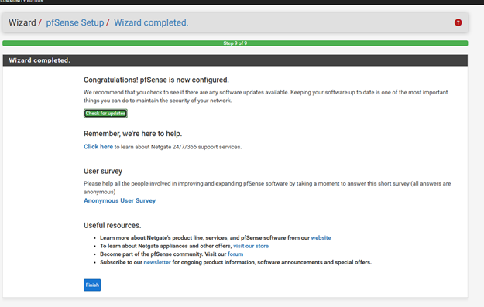

Then Finally “Reload” to your new PFSENSE Firewall